Investigating a Suspicious Phishing Email – SOC Analysis Report

Executive Summary :-

Phishing remains one of the most common attack vectors used by adversaries to gain unauthorized access to corporate environments. These attacks rely on social engineering techniques to trick users into revealing sensitive information, clicking malicious links, or executing malicious attachments. Even in organizations with strong security controls, phishing emails may still bypass filters and reach users’ inboxes.

This investigation analyses a suspicious email reported to the security team. The objective was to determine whether the email represented a legitimate communication or a phishing attempt designed to deceive recipients. The investigation involved reviewing email header metadata, analysing sender information, extracting links and attachments, and evaluating indicators of compromise using threat intelligence and reputation analysis tools.

During the investigation, multiple indicators commonly associated with phishing campaigns were identified. These included a spoofed sender address attempting to impersonate a legitimate company, the use of urgency within the subject line and message body, and link manipulation designed to redirect the user to an external malicious destination. Additional analysis revealed inconsistencies between the sender’s display name and the actual sending domain.

Based on the collected evidence and analysis, the email was determined to be a confirmed phishing attempt intended to manipulate recipients into interacting with malicious content.

Alert Details

Alert Type: Suspicious Email Report
Severity: Medium
Category: Phishing / Social Engineering
Detection Source: User-reported suspicious email

Investigation Objective

The purpose of the investigation was to determine whether the reported email represented a legitimate message or a malicious phishing attempt. The analysis focused on identifying indicators commonly associated with phishing attacks, such as spoofed sender identities, malicious links, suspicious attachments, and abnormal email header behaviour.

Investigation Process

Phishing analysis typically involves examining two key components of an email message:

Email Header – contains technical information about the email’s origin and the servers that handled its transmission.

Email Body – contains the visible message, hyperlinks, attachments, and other content intended for the recipient.

The analysis began with reviewing the email header fields to collect key metadata relevant to the investigation. Important header attributes examined included:

Sender email address

Sender IP address

Recipient address

Subject line

Reply-to address

Date and time of transmission

Reviewing these fields can help identify whether the email originated from the domain it claims to represent or if it was spoofed by an attacker.

Following header analysis, attention shifted to the email body and embedded content. The message was inspected for social engineering techniques commonly used in phishing campaigns. These techniques often include impersonation of trusted organizations, urgent language intended to pressure the recipient into immediate action, and embedded hyperlinks designed to redirect the user to fraudulent websites.

Any URLs present within the email were extracted and inspected to determine their true destination. If URL shortening services or hidden links were used, additional analysis was conducted to reveal the underlying domain.

Finally, attachments associated with the email were analysed by generating cryptographic file hashes and verifying their reputation using threat intelligence platforms. This step helps determine whether the attachment has previously been identified as malicious.

Evidence Collected:-
Evidence 1 — Spoofed Sender Address

One of the first indicators identified during the investigation was the presence of a spoofed sender address. The email appeared to originate from a legitimate service provider, but the actual sending domain did not match the organization being impersonated.

This mismatch between the display name and the underlying email address is a common phishing tactic used to trick recipients into trusting the message.

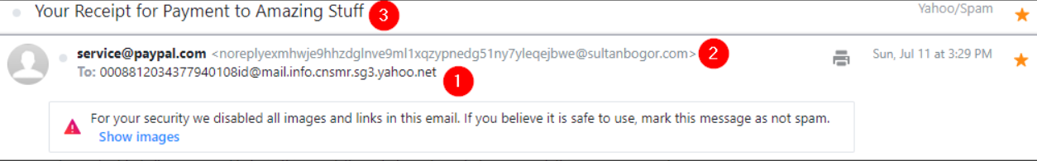
Figure 1 — Suspicious email header showing a spoofed sender identity impersonating PayPal while originating from an unrelated domain.
Evidence 2 — Social Engineering and Urgency

The subject line and message content were designed to create a sense of urgency.
Examples included warnings such as account suspension, billing issues, or pending deliveries.

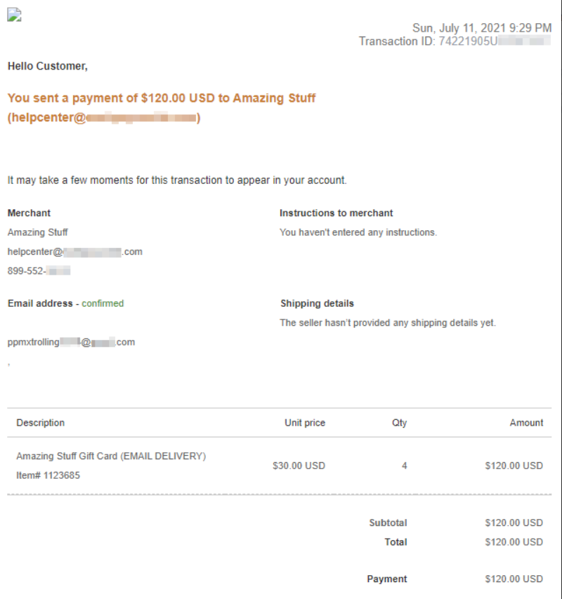
Figure 2 — Phishing email body impersonating a PayPal payment receipt designed to pressure the recipient into reacting quickly.

These techniques are commonly used in phishing campaigns to pressure recipients into reacting quickly without verifying the authenticity of the message.

Evidence 3 — Link Manipulation

The email contained embedded hyperlinks intended to redirect the recipient to an external website. While the displayed text suggested a legitimate destination, the actual URL pointed to a different domain.

Link manipulation is frequently used in phishing attacks to redirect victims to credential harvesting websites designed to capture usernames, passwords, or other sensitive information.
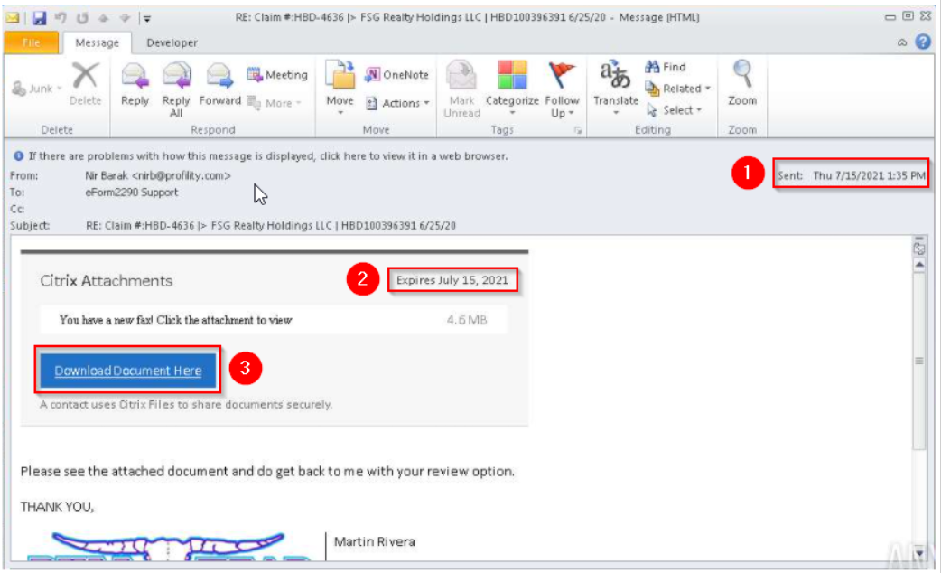
Figure 3 — Phishing email containing an embedded download button designed to redirect the recipient to a malicious document delivery site.
As shown in Figure 3, the email includes several phishing indicators, such as the message timestamp (1), an urgency trigger through the expiration notice (2), and a call-to-action button prompting the user to download the document (3).

Evidence 4 — Malicious Attachments

Some phishing campaigns also deliver malicious payloads through attachments disguised as legitimate documents. In this case, the attachment appeared to be a common file type used in business communications.

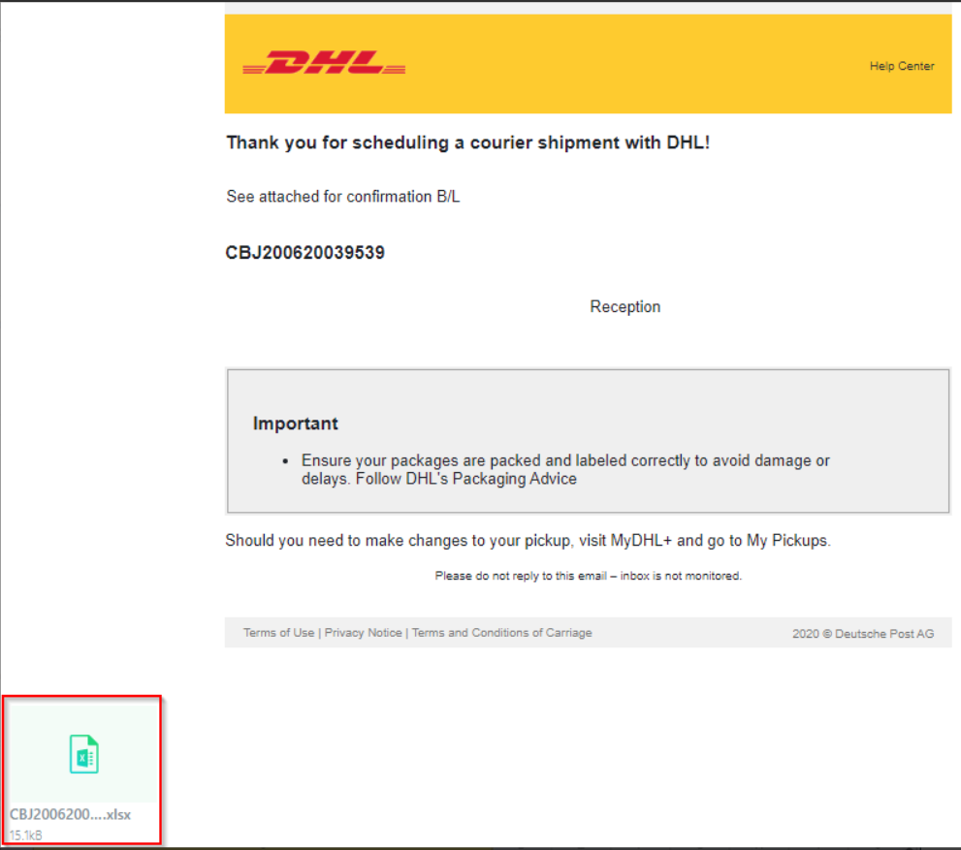

Attachments were analysed by calculating their SHA256 hash values and verifying them against threat intelligence databases. This process helps determine whether the file has previously been identified as malware or associated with malicious campaigns.

The investigation revealed several indicators consistent with phishing activity. The sender’s email address did not match the organization it claimed to represent, suggesting email spoofing. The message content used urgent language designed to pressure the recipient into taking immediate action. Additionally, embedded hyperlinks were manipulated to redirect the recipient to an external domain.

These characteristics strongly align with common phishing techniques used to harvest credentials or deliver malicious payloads.

Final Assessment

True Positive – Confirmed Phishing Email

The email demonstrates multiple indicators associated with phishing campaigns and should be classified as malicious.

Recommendations

To reduce the risk of similar phishing attacks in the future, several defensive measures should be implemented:

Email Authentication Controls

Organizations should implement authentication mechanisms such as:

SPF (Sender Policy Framework) – validates that emails originate from authorized mail servers.

DKIM (DomainKeys Identified Mail) – verifies the integrity of email messages using cryptographic signatures.

DMARC (Domain-based Message Authentication, Reporting, and Conformance) – enforces policies to prevent domain spoofing.

These technologies help detect and prevent fraudulent emails from impersonating legitimate domains.

Security Awareness Training

Employees should receive regular training on identifying phishing indicators such as suspicious links, unusual sender addresses, and urgent requests for sensitive information.

Attachment and URL Scanning

Email security solutions should automatically scan attachments and links for malicious content before delivering messages to users.

Incident Reporting Procedures

Organizations should maintain clear procedures that allow employees to quickly report suspicious emails to the security team for investigation.

This investigation was conducted in a controlled training environment using simulated phishing samples for educational and portfolio purposes.

